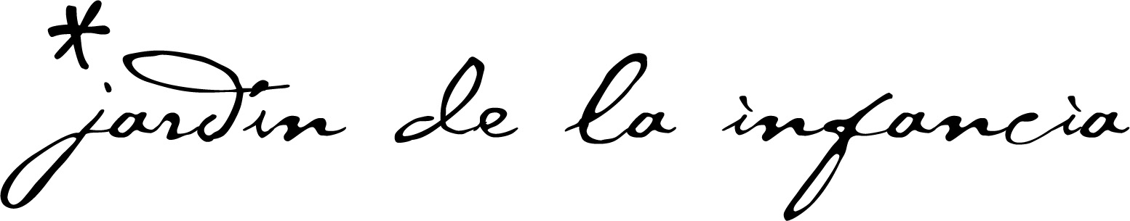

REGULAR BOARD MEETING AGENDA
JARDIN DE LA INFANCIA CHARTER SCHOOL
BOARD OF DIRECTORS
Date: Friday, September 26, 2025
Time: 8:30 a.m.
Location: 1400 S. Broadway, Los Angeles, CA 90015

The meeting can be attended via zoom: Meeting ID: 850 3414 4905
Passcode: 766322
The meeting can be attended via teleconference: 1-669-900-6833
Meeting ID: 850 3414 4905
Passcode: 766322

Call in Locations:
1400 S. Broadway, Los Angeles, CA 90015
345 East Colorado Blvd. #301, Pasadena, CA 91101
3109 Pine Avenue, Manhattan Beach, California 90266
2400 John Street, Manhattan Beach, CA 90266
222 South Grand Avenue, Pasadena, California 91105

INSTRUCTIONS FOR PRESENTATIONS TO THE BOARD BY PARENTS AND CITIZENS
Jardin de la Infancia welcomes your participation at the School’s Board meetings. The purpose of a public meeting of the Board of Directors (“Board”) is to conduct the affairs of the school in public. We are pleased that you are in attendance and hope that you will visit these meetings often. Your participation assures us of continuing community interest in our School. To assist you in the ease of speaking/participating in our meetings, the following guidelines are provided:

Agendas are available to all audience members at the door to the meeting.

Any public records relating to an agenda item for an open session of the Board which are distributed to all, or a majority of all, of the Board members shall be available prior to the meeting for public inspection. Copies of these documents will also be made available at the meeting. A permanent copy of all meeting-related documents will be maintained on site at the school.

“Request to Speak” forms are available to all audience members who wish to speak on any agenda items or under the general category of “Oral Communications.” “Oral Communications” is set aside for members of the audience to raise issues that are not specifically on the agenda. However, due to public meeting laws, the Board can only listen to your issue, not respond, or take action. These presentations are limited to three (3) minutes and total time allotted to non-agenda items will not exceed fifteen (15) minutes. The Board may give direction to staff to respond to your concern or the item may be added to future meeting agenda.

You may also complete a “Request to Speak” form to address the Board on Agenda items. With regard to such agenda items, you may specify that agenda item on your “Request to Speak” form and you will be given an opportunity to speak for up to five (5) minutes when the Board discusses that item; however, if there are a large number of speakers per item the per speaker amount of time may be reduced or a cap may be placed on the total time for public comment.

When addressing the Board, speakers are requested to state their name and address from the podium and adhere to the time limits set forth.

In accordance with Government Code Section 54953.5, the public may obtain a copy, at cost, of a recording made by the Board of its public sessions and may listen to or view the Board’s original recording on a listening or viewing device provided by the school.

This Board meeting is held in compliance with the Americans with Disabilities Act. In compliance with the Americans with Disabilities Act (ADA) and upon request, the school may furnish reasonable auxiliary aids and services to qualified individuals with disabilities. Individuals who require appropriate alternative modification of the agenda in order participate in Board meetings are invited to contact the Director at (213) 614-1745.

I. PRELIMINARY

A. CALL TO ORDER

Meeting was called to order by the Board Chair at .

B. ROLL CALL
Present Absent
Alice Callaghan ______ ______
Mike Roos ______ ______
Gerald Secundy ______ ______
Patricia Torrey ______ ______
Paul White ______ ______
Robert Wycoff ______ ______

II. ITEMS SCHEDULED FOR ACTION

  - 9/17/25 Board Meeting Minutes
  - June 2025 Financials
  - 24-25 Unaudited Actuals Report
  - 24-25 Audit
  - 24-25 Tax Return
  - August 2025 Financials
  - 24/25 Arts & Music in Schools Report

- ITEMS SCHEDULED FOR DISCUSSION

IV. PUBLIC TESTIMONY

V. ADJOURNMENT

The meeting will be adjourned at ______________.

